CS 340 README Template

About the Project/Project Title
CRUD is an important functionality for interacting data in databases. This project creates a Python module AnimalShelter, that gives the user an object-orientated interface to perform Create and Read CRUD actions on a MongoDB database. The create functionality intakes a Python dictionary that represents an animal record, validates it, and inserts it into the database. A confirmed insert returns True while a failure returns False. The read functionality intakes a validated Python dictionary representing one’s search criteria. Once found, data is returned in list format. If no data is found an empty list is returned to the user. The update and delete functions operate similarly. Passed in data is validated and if the data matches it is either updated or deleted, the count of the number of records update or deleted is returned.

Motivation
The goal of this project was to create an easy, reliable, and reusable way for a user to add and read data from a database. Data and query inputs are validated for the user, so the program fails in a safe way. Return types are consistent so that data being returned can reliably be used to populate a dashboard.

Getting Started
The database this module works with is the Austin Animal Center database or for short, the aac database, with the corresponding collection of animals. A new user account has been provisioned for this database. Enter the connection command to connect to the database with the new user account. You will be prompted for the password. To see the databases available type ‘show dbs’, to use the aac simply type úse aac’ and to see the collections type ‘show collections’. The screenshot below shows the database connection command and the show dbs command.

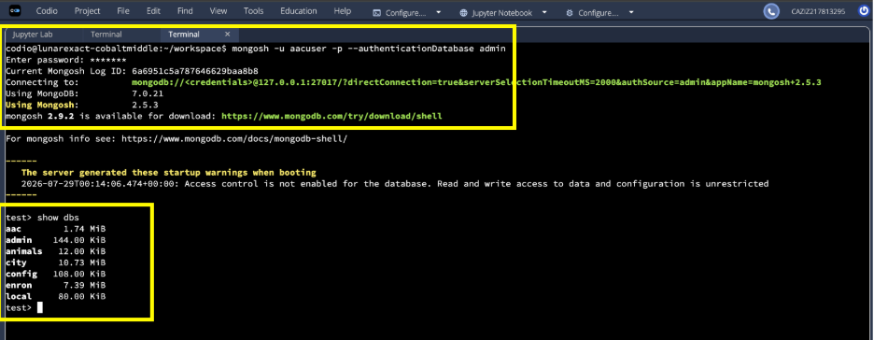

The create section includes a simple data validation. If there is data, insert it into the database and if that is successful print a message and ‘True’, if not, print False and a message. If there is no data inserted return False and a message. The read method creates an empty list, and checks if there is search data passed in, if not it prints a message and returns an empty list, is so it returns the items in a list. Some technical challenges entailed the read method returning a cursor and not usable data. I reworked the code to force the data into a list, this allowed viewing the data. Creating a new user was mostly smooth, but somehow I created the new user in a different database, so had to recreate the user in the proper database.

Installation
To use this project, you will need PyMongo, Jupyter Notebook, BSON, MongoDB and Python 3 on your system to connect and run the tests.

Python3: To check if this is installed run ‘python3 –version’ in your terminal. If no version is returned refer to the Python official downloads page to download onto your system.
MongoDB: The database used for this project. You must either have this running locally or have access. Refer to download and start instruction here: https://www.mongodb.com/try/download/community
PyMongo: This is the Python driver for MongoDB and is used to connect to the database, complete database selections and perform CRUD operations. To install in bash use ‘python -m pip install pymongo’.
BSON: This is integral to the way MongoDb stores documents. This is installed with PyMongo, but to use it import it in your project via ‘from bson.objectid import ObjectId’.
Jupyter Notebook: Jupyter Notebook provides an interactive environment for testing. Cells appear just below the code so test output can clearly be viewed. To install simply ‘pip install notebook’.

Usage
To use the CRUD module you must import it into your project with your file path and instantiate it. At this point the available operations are create and read. The import command and execution can be seen in the following screenshot.
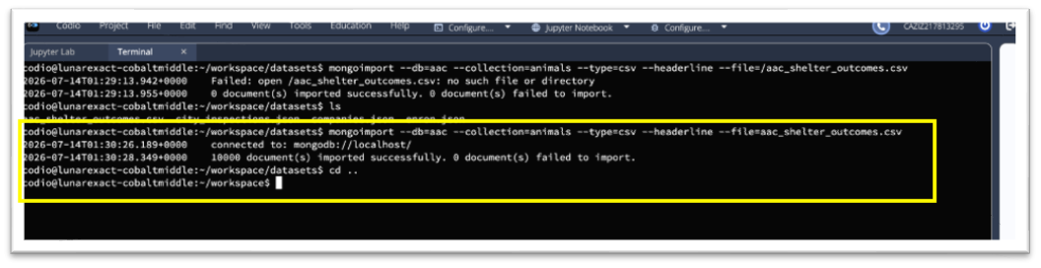

Code Example
Once you have imported the module, you will be able to instantiate the class. To read from the database use your instance with the read functionality and pass in your search parameters in dictionary format. See the example code below.
Your_Instance = AnimalShelter()
<your_Instance>.read({"breed":"Dalmation"})

To insert data into the database, use your instance and the create functionality to pass in your data in dictionary format. See code example below.
data = {
"age_upon_outcome": "1 day",
"breed":"Dalmation",
"animal_type": "Dog",
"color": 'Black/White',
"date_of_birth": '2026-07-18',
"datetime": '2026-07-21 11:05:00',
"monthyear": '2026-07-21T11:05:00',
"name": "Pongo",
"outcome_type": "Transfer"
}
<your_Instance>.create(data)

If the data successfully inserts you will see True and a success message and if it fails, you will see False along with an error message.

Tests
The tests are in the Jupyter notebook under ModuleFourTestScript.ipynb. An instance of AnimalShelter has been instantiated, test data has been created for the various CRUD operations. The user only must push the play button to run all tests and view output. If you need any tests to fail adjust based on the code.

Screenshots
To run all tests hit the play button in the image below:
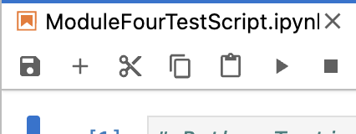
To create or insert a new test record into the database, create data in dictionary format and pass it to the create method. Please see screenshot below. In the example below the dictionary new_pup is already created in the notebook.
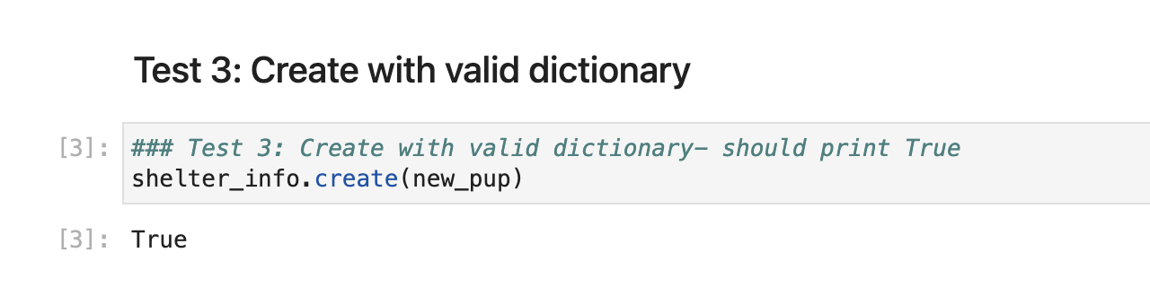
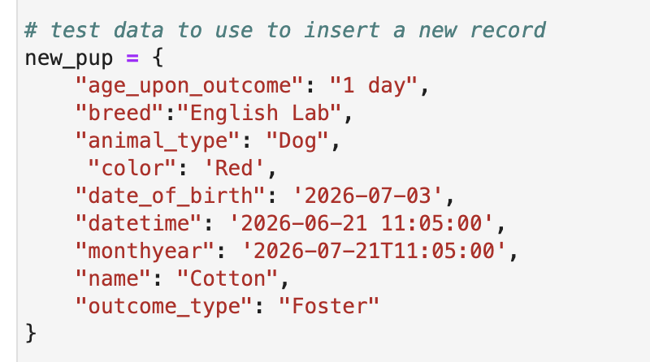

To read inserted test data from the database use the instantiated instance and the read method passing in data in dictionary format. When you hit the play button if you have entered an animal in the database you will see the record printed out.

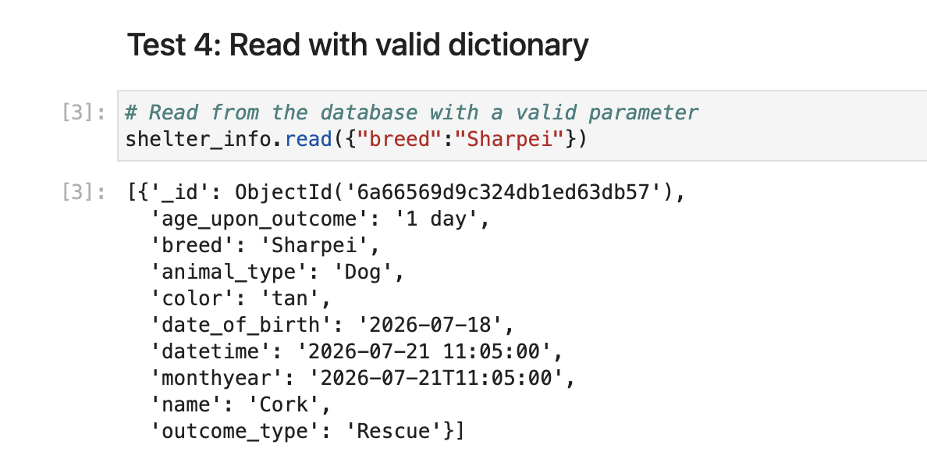

If reading fails, you will get back an empty list. You will get a failure with invalid data and if there is not data matching your search in the database.
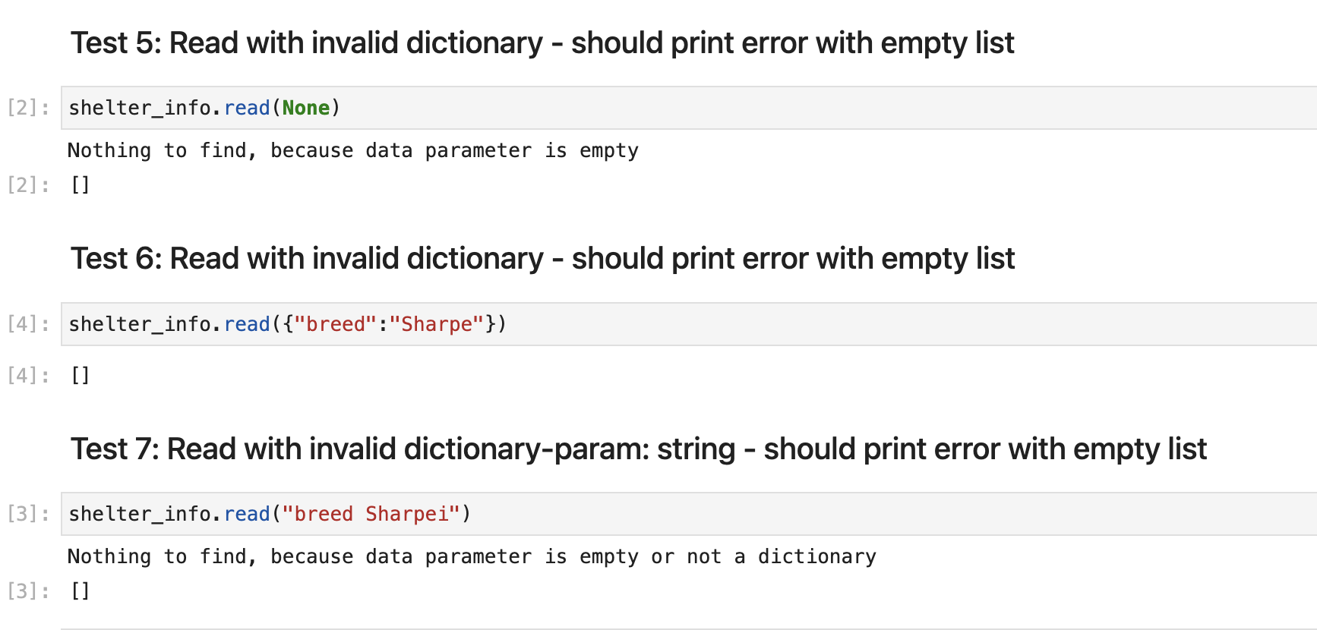

Updating the database:
There are four tests for update functionality. Three tests to demonstrate invalid data or what happens when nothing if found to update and one test to successfully update records in the database. The screenshots below show all update tests in the notebook.
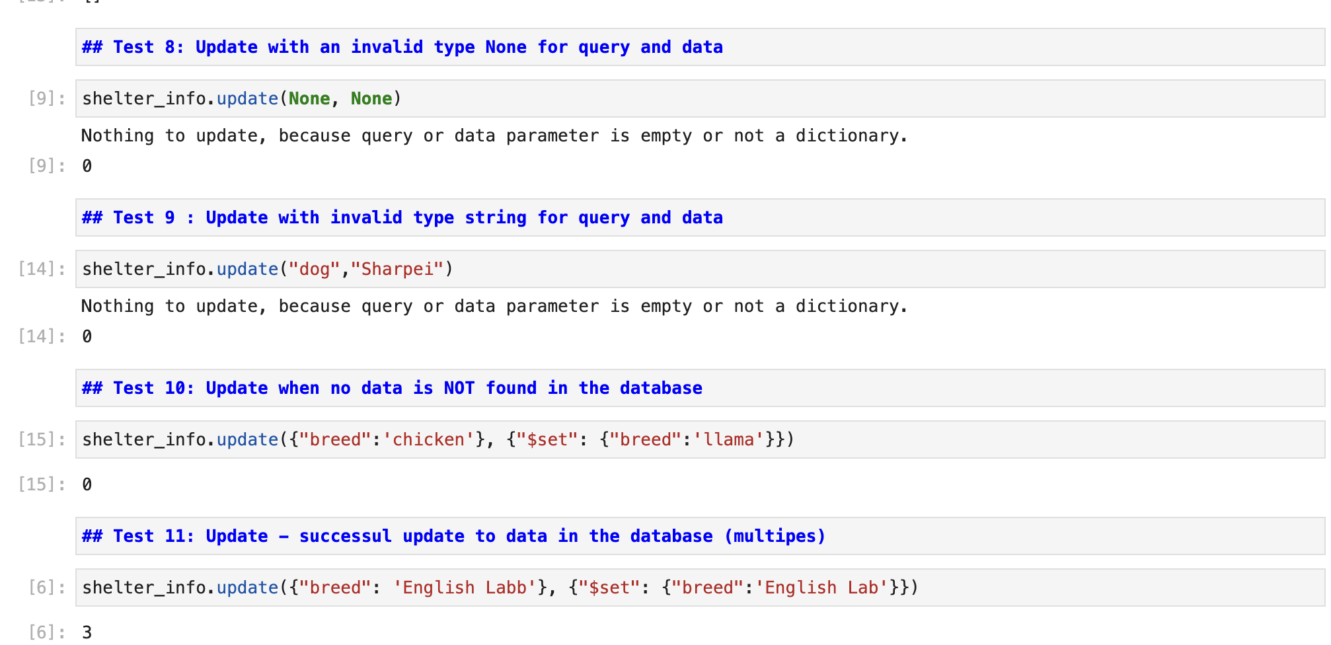
Deleting data from the database:
There are four tests to show delete functionality. Three error tests that show either invalid input or what happens when data is not found and one test that successfully deletes data from the database and the count of the records that are deleted. The screenshot below showcases all scenarios in the notebook.
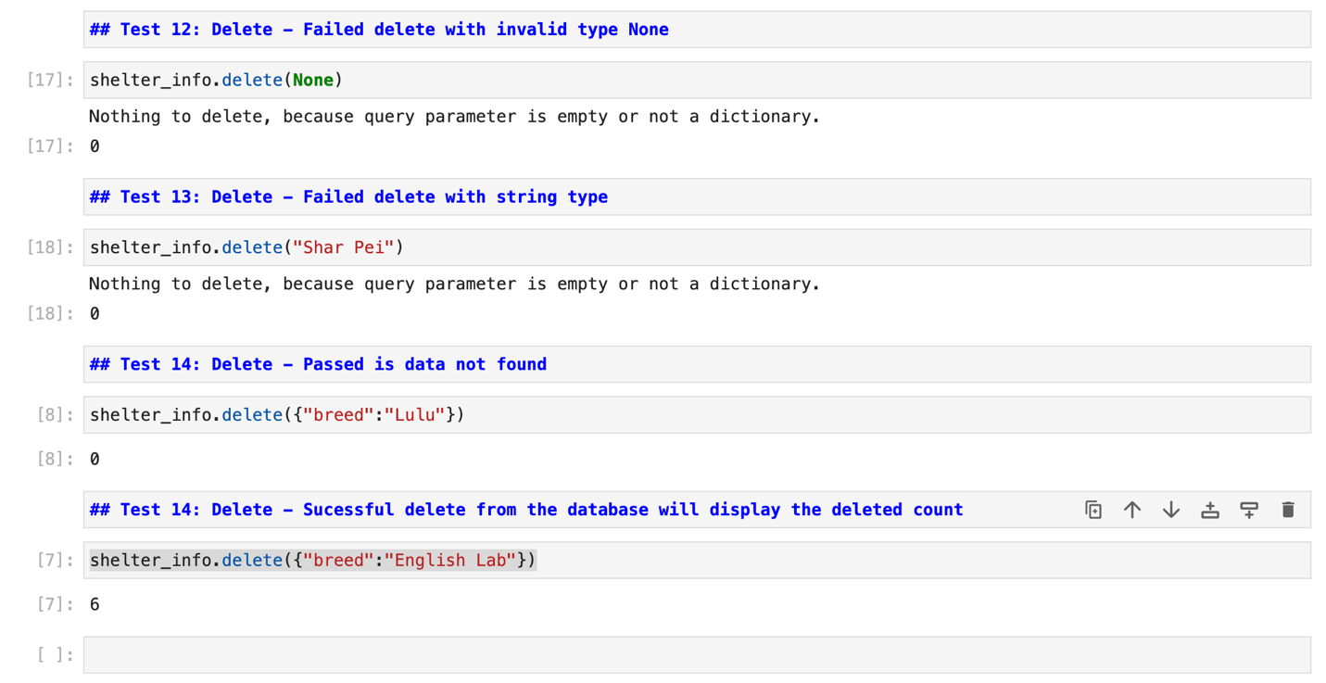

Contact
Your name: Chiara Aziz

